R Telecom churn predictive model

Test case 1 – Validating data Frame shape

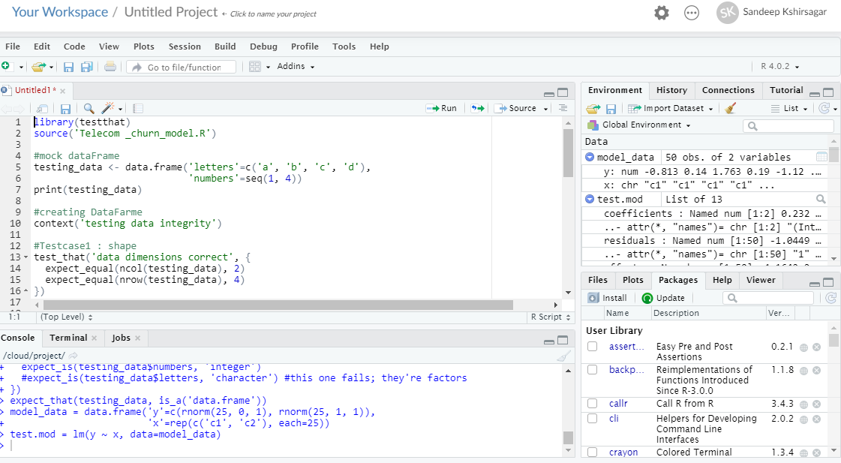

Test case 2 – Validating missing datapoints

Test case 3 – Validating data types

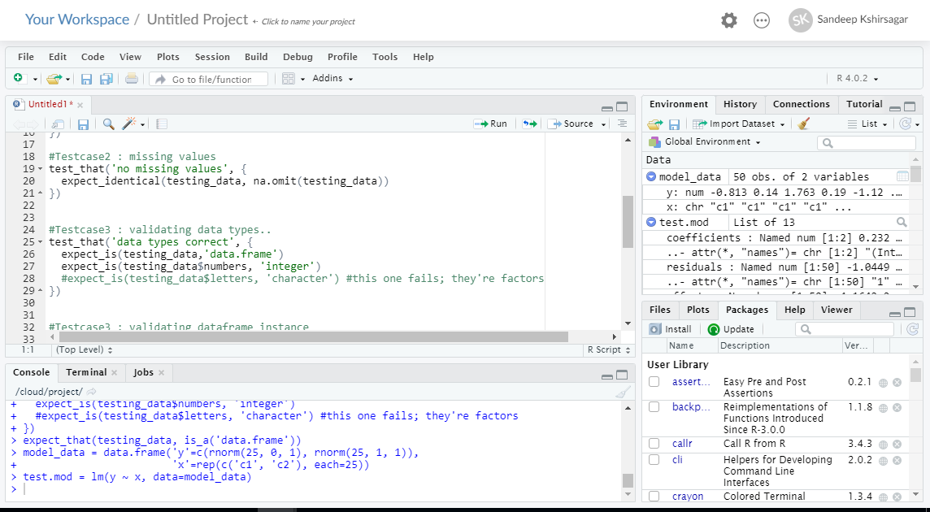

Test case 4 – Validating data frame instance for test data

Test case 5 – Validating model parameters

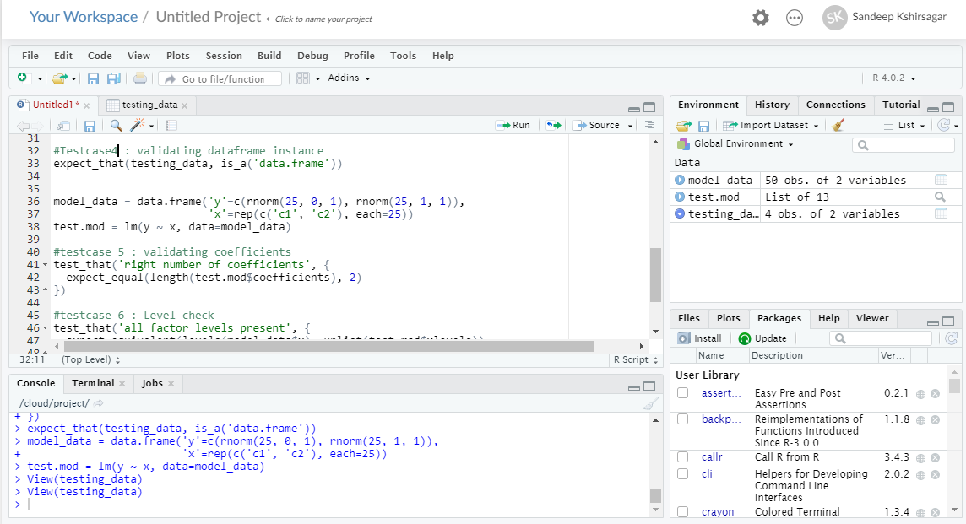

Test case 6 – Validating nimber of levels

Test case 7 – Validating test data distribution (central tendencies)

